 AI 894: Design & Implementation of AI Systems

Comparison Between YOLO and SSD Algorithms for Video Real Time Object Detection

Team 8
Dagmar Mojena Carrazana
Joshua Pauly
Josue Perez Gomez

Master of Artificial Intelligence (AI)
Spring 2025

Instructor: Dr. Chengfei Wang

Work carried out by:
Members | Email Address
Dagmar Mojena Carrazana | dzm6070@psu.edu
Joshua Pauly | jfp5940@psu.edu
Josue Perez Gomez | jkp5482@psu.edu

TABLE OF CONTENT
Abstract 3
Introduction 3
Literature Review 5
Methodology 6
Result 12
Conclusion 15
References 16

Abstract
This capstone project has the purpose of analyzing and comparing two popular one-shot object detection algorithms. The You Only Look Once (YOLO) and the Single-Shot Detector (SSD) models. In contrast to other popular object detection techniques, the SDD and YOLO object detection algorithms are newer and are designed for the purpose of real-time object detection, thus faster in evaluating input images. This project compares the performance of both object detection algorithms using an open-source data repository of video recordings from car dashcam videos called Agroverse-HD. On top of evaluating the performance, this project has the additional purpose of introducing, explaining and showing possible applications of both the YOLO and SSD object detection models.
This project used existing pre-trained and open-source models. The YOLO model from a Python package called Ultralytics and the SSD model from PyTorch. Both models were then fined tuned with the training section of the Agroverse-HD data for a fair comparison. The data was augmented and transformed to fit the model requirements. Some of the important metrics used to compare both models included accuracy, recall, precision and inference time. Finally, a demonstration of how the models enclose the desired class objects with a bounding box is shown on test data.
With the results and interpretation of the comparison between both object detection models, one can more easily pick a model that best fits their requirements, for runtime and accuracy.

Introduction
In the field of artificial intelligence there are many areas of study, one of which is computer vision. Computer vision is the study of how computers can read and understand images that humans instantly interpret. Traditional uses of object detection applications are surveillance video and most recently in transportation, however high-performance models are too expensive to run and are in most cases not optimal for real-time object detection, due to their high accuracy [1]. As micro-devices and micro-computers are more accessible, applications such as self-driving cars and robotics are expanding, both of which require a quick and accurate response to real-time input. This is where models like SSD and YOLO play a role, given they are two of the most popular real-time object detection algorithms. The importance of these two models is that unlike previous models, SSD and YOLO can process input images in a single forward pass making faster, with the slight trade-off on performance. However, YOLO and SSD also have a trade-off within themselves as specialized real-time object detection algorithms, that is accuracy and run time. YOLO being the fastest while SSD balances run time with performance, however both models can work with and handle more frames per second than previous models [2][3].
In this project the comparison between the YOLO and SSD object detection models are tested, evaluated and explained with the purpose of providing more insight and proof on their strengths, weaknesses and trade-offs. Using real-time video image and open-source pre-trained models the project explores fine tuning with video input and augmented data of that video input. The project also goes into the evaluation of both models, by comparing metrics such as accuracy, recall and Mean Average Precision(mAP). The expectation is that the fine-tuned YOLO model will be faster than the fine-tuned SSD model but not as accurate. The project explains in detail how SSD and YOLO work, which explains their differences and trade-offs.
Additionally, the project provides detailed information and description of the video-image and characteristics. Information on the pre-trained opensource YOLO and SSD models are explained such as their background and architecture, as well as details on the hyperparameter tunning. A workflow is also presented, which shows the overall process done, starting from collecting the data to showing the results and conclusions. An in-depth description of the model creation using its respective Python packages is explained, as well as description on fine-tunning and its findings are presented. Finally supporting scores tables and confusion matrices are provided to show the comparison metrics of both models, closing with a conclusion on the findings of the process and some observation notes.
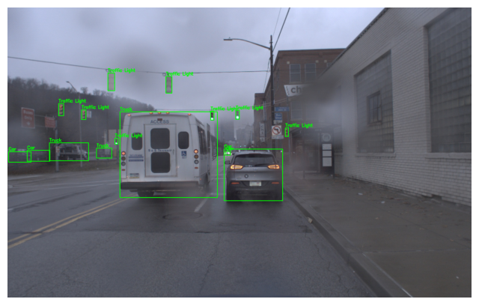
Fig. 1: Expected result from the SSD and YOLO models. The video image with bounding boxes on the class objects along with the classification prediction labels

Literature Review
As computers and hardware become more powerful, this allows for new techniques to be considered and developed that might be more demanding in computing. Additionally, with the increase of micro-computers, more applications can be done, such as image processing.
As mentioned, the applications of object detection algorithms/models are many, such as self-driving cars, enhanced security cameras, robotics and more. A lot of work has been done on developing new techniques to better detect people, cars, trucks, motorcycles and all sorts of different objects. For instance, methods such as the Faster R-CNN make use of fully convolutional network layers to propose possible boxes that might capture objects based on the feature maps from the CNN [2]. However, previous works such as Faster R-CNN, Fast R-CNN and R-CNN lack the ability to process real time inputs, Faster R-CNN being the best, still performs 2.5 times slower than YOLO and SSD architectures [3]. As such the need to use an object detection model that is suitable for real-time input is useful.
The main differences between the previous models in comparison to YOLO and SSD models is how predicted box locations are predicted. Methods like Fast R-CNN make use of selective search that are more time consuming than neural networks, which is used on Faster R-CNN, however they still make use of Region Proposal Networks which are fully connected CNNs that predict bounds, and class scores and then classifies the predicted class scores and fixes its bounds [3]. As a result, previous models like Faster R-CNN are slower and more computationally expensive, because of the extra classification step. In contrast, YOLO and SSD models only perform a single process avoiding the additional classification.
For YOLO, the approach is like Faster R-CNN, it uses a backbone network, such as VGG-16, to get the feature maps. The difference is that it combines the two steps of generating the bounding boxes and classification scores from the feature maps with the classification of the generated classification scores into a single stage. Additionally, YOLO uses fewer bounding boxes and has constraints on such boxes to avoid detecting the same object many times. The result of this architecture is a fast real-time object detector, with the small trade-off of less accurate results compared to older models, especially on small objects [3].
For SSD, like YOLO it too makes object detection into a single forward process, however instead of using a simple fully connected CNN and Neural Network like YOLO, SSD creates a hierarchical list of feature maps at different scales as it processes the image. It then predicts the bounding boxes and scores at those different scales, this results in better scores than YOLO, especially for small objects. However, due to the multiple features at different scales, SSD is slower than YOLO, thereby trading some accuracy over run time [4].
This project is different from other similar work, in the sense that the main purpose is to make a comparison between existing pre-trained YOLO and SSD models, which are more likely to be used for business applications that are more interested in successful and simplicity of implementation rather than proprietary development code. Most importantly, the model comparison provides conclusions and results on the drawbacks and performance difference between them. However, there is a gap in this project, which is that the level of granularity for the applications could be further explored, this means being able to demonstrate a functional video surveillance camera with either model running inside such video systems. This kind of live demonstration can be done as future work, now that this project compared the performance and trade-offs from both YOLO and SSD models.

Methodology
This section outlines the setup used to compare the two most widely used real time object detection models YOLO and SSD on road scene data from Agroverse-HD dataset. The methodology includes a detailed overview of the dataset, preprocessing steps, model architectures, training configurations and evaluation metrics. By training both models on the same dataset, this project ensures a fair and reproducible comparison.
The dataset used in this project is Argoverse-HD dataset [5]. Agroverse-HD dataset is a high-frame-rate object detection dataset derived from the Agroverse 1.1 autonomous driving dataset. It has been designed specifically for streaming evaluation, but it can also be used for research in image and video object detection. The annotations follow the COCO format and are stored in a JSON file. Argoverse-HD contains high-frame-rate video sequences with annotations for 8 different object classes: person, bicycle, car, motorcycle, bus, truck, traffic light, and stop sign. The total size of the dataset is 29.3 GB, and it includes both image files and corresponding annotation files. The dataset is publicly available on Kaggle under the title "ArgoverseHD" at https://www.kaggle.com/datasets/mtlics/argoversehd, where it can be downloaded and used for object detection research.
Data preprocessing is a critical step in preparing the Argoverse-HD dataset for training SSD and YOLO object detection models. The dataset consists of high-frame-rate video footage converted into JPEG images, with corresponding annotations stored in a COCO-style JSON file. To ensure consistent input for the models, all images were resized to match the input requirements. For the SSD Model images had to be resized to 300×300 and same for the corresponding boundary boxes. The annotation file, which includes object labels for person, bicycle, car, motorcycle, bus, truck, traffic light, and stop sign, was converted to the required format for each model: YOLO expects annotations in the normalized [class_id, x_center, y_center, width, height] format, while SSD uses the [xmin, ymin, xmax, ymax, class_id] format. To use Ultralytics Yolo11 model the JSON file had to be converted to a text file. The text file and conversion for the dataset were provided by Ultralytics. [6]
A common issue with street data is the imbalance of objects encountered on the road. In the Agrovers-HD dataset, the “car” class are by far the most abundant of any class, being 63% of all objects (see Fig. 2.1). To address this imbalance and improve overall model performance, this project applied data augmentation in the form of copy and paste technique [7]. Copy and pasting techniques were used to copy the underrepresented classes into images that lacked diversity. As a result, the updated class distribution reflects a more balanced dataset. While the “car” class is still 53% of the new training dataset the classes with the fewest instances were raised to a minimum of 50,000 (see Fig. 2.2). Achieving a greater class distribution is critical, as it reduces the difference of accuracies between classes. Augmentations such as blurring, brightening, contrast changes and hue shift were applied to the dataset.
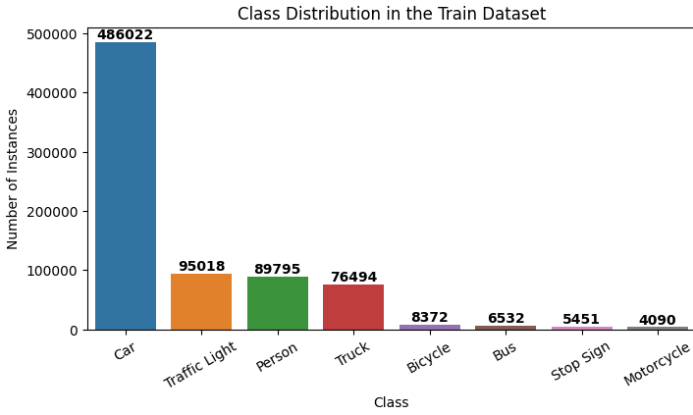
Fig. 2.1: Base Class distribution of training dataset
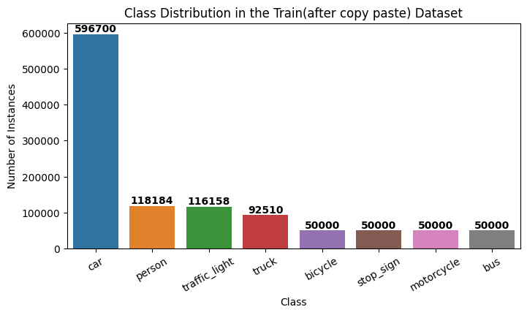
Fig. 2.2: Class distribution of training dataset after copy and paste method

The YOLO (You Only Look Once) model is a real-time, one-stage object detector that simultaneously predicts bounding boxes and class probabilities directly from full images using a single neural network. The network divides the input image into a 7x7 grid, with each grid cell responsible for predicting bounding boxes and their corresponding confidence scores, along with class probabilities. The architecture comprises 24 convolutional layers followed by 2 fully connected layers, utilizing leaky ReLU activations throughout, except for the final linear activation in the output layer. While YOLO offers significant speed advantages over traditional two-stage detectors, it exhibits limitations in accurately localizing small objects and handling multiple objects in close proximity, due to its coarse grid-based prediction mechanism. [4] YOLOv11 introduces several architectural enhancements over the original YOLO model, significantly improving performance in real-time object detection tasks. Changes include the integration of the C3k2 block, which enhances feature extraction efficiency, and the Spatial Pyramid Pooling Fast (SPPF) module, which captures multi-scale contextual information more effectively. These changes make YOLOv11's have superior accuracy and speed compared to its predecessors. [8] A positive about using Ultralytics YOLO11 model is that it is very well maintained along with the libraries to train and evaluate it. The train function from Ultralytics includes many features, including useful augmentations. The train function uses two loss functions. Box loss/ also called IOU loss function which measures how close the predicted bounding box is to the ground truth boxes. Classification loss which measures how well the model classifies the classes. Since the data was already augmented, most of them were deactivated. After experimentation, the best-performing hyperparameters for YOLO were determined to be learning rate = 0.0001, weight decay = 0.01, patience = 5, batch size =16 and optimizer = AdamW. It took 12 epochs to reach the best weights, and the training was terminated at 17 epochs after no improvement was made preventing overfitting.
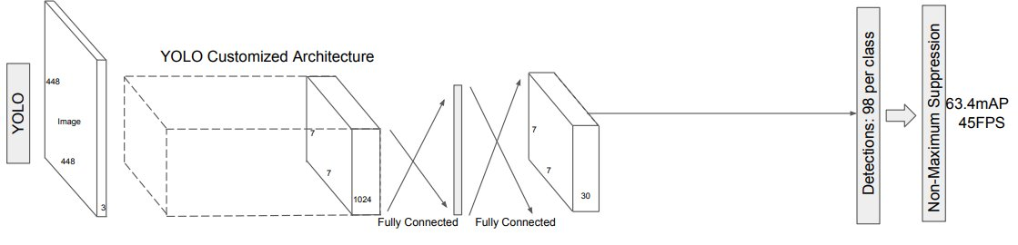Fig. 3: The architecture comprises 24 convolutional layers followed by 2 fully connected layers. The convolutional layers are responsible for feature extraction, capturing spatial hierarchies in the input image, while the fully connected layers predict the bounding box coordinates and class probabilities. The network divides the input image into a 7x7 grid, and each grid cell predicts bounding boxes, confidence scores for those boxes, and class probabilities. [4]
The Single Shot MultiBox Detector (SSD) is a one-stage object detection model that performs object localization and classification in a single forward pass using multiple convolutional feature maps of different resolutions. SSD achieves this by discretizing the output space of bounding boxes into a set of default boxes of various aspect ratios and scales at each feature map location. During prediction, the model generates scores for the presence of each object category in each default box and adjusts the box to better match the object shape. A key innovation in SSD is its use of multiple feature maps from different stages of the base network, allowing it to detect objects of various sizes effectively.[4] One drawback of this architecture is that it requires 300x300 image input. The two loss functions, classification and IOU loss functions were used for training the model. After multiple experimentations with hyperparameters the best performing were determined to be learning rate = 0.00005, weight decay = 0.001, patience = 10, optimizer = AdamW. StepLR scheduler was used to reduce the learning rate by 0.5 after the 3rd epoch. After 16 epochs early stopping kicked in to prevent overfitting.
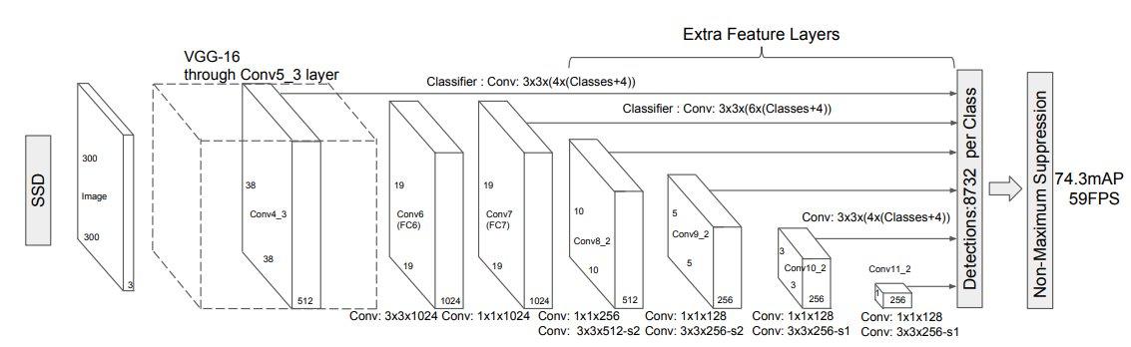Fig. 4: SSD architecture uses a modified VGG-16 network as its backbone requiring a 300x300 image input. Fully connected layers are replaced with convolutional layers to extract high-level image features. Additional convolutional layers are appended to progressively smaller feature maps, enabling multi-scale object detection by predicting class scores and bounding boxes directly from multiple resolutions. [3]
Differing training needs of the two models resulted in the use of different hardware specs when training the model. YOLO11 model training was conducted using personal hardware on a NVIDIA GeForce RTX 4090 GPU. The computing needs required for SSD were greater resulting in the need of using Google Colab Pro, leveraging an NVIDIA A100 GPU to accelerate training and inference processes. YOLO11 utilized Ultralytics python library [8] and SSD used PyTorch python library. YOLO11 being a lighter model allowed for easier training on a more limited GPU than SSD.
To assess and compare the performance of the YOLO and SSD models, several evaluation metrics were used, including class-wise recall and mean Average Precision (mAP), confusion matrix, and inference time(ms). Recall measures the ability of the model to detect all true occurrences of a class [10]. mAP@50 (mean Average Precision at 0.5 IoU) evaluates detection accuracy when predicted bounding boxes have at least 50% overlap with ground truth. mAP@50:95 provides a more comprehensive view by averaging mAP across multiple IoU thresholds (from 0.5 to 0.95 in 0.05 increments), penalizing less precise predictions. These metrics show how accurately each model identifies and localizes objects across all classes. [11] Inference time is calculated in milliseconds and is useful for comparing how fast the models are at predicting an object. To match 60 FPS video the model needs to have an inference speed of less than 16.67 ms. The calculations for recall, mAP@50 and mAP@50:95 is below:
Recall = True Positives / (True Positives + False Negatives)
$$\text{mAP@50}=\frac{1}{N}\sum_{i=1}^{N}{{\text{AP}}_{i}^{\text{IoU}=0.50}}$$
Where N = number of classes and ${\text{AP}}_{i}^{\text{IoU}=0.50}$is the average precision for class i at IoU threshold t.
Since this project breaks down each class N = 1 in this equation
$$\text{mAP@50:95}=\frac{1}{10}\sum_{t=0.50}^{0.95}{\left(\frac{1}{N}\sum_{i=1}^{N}{{\text{AP}}_{i}^{\text{IoU}=t}}\right)}$$
This involves computing the AP for each class at each IoU threshold t, then averaging over all classes and thresholds. In this project each class is calculated separately N = 1.

To provide a high-level overview of the workflow, Fig. 5 presents a flow diagram outlining each major step of the process. Workflow begins with the acquisition of the Argoverse-HD dataset and model research, followed by analysis of the data. The next steps were building and training the YOLO and SSD models. This is followed by the last step of comparing the YOLO and SSD results.
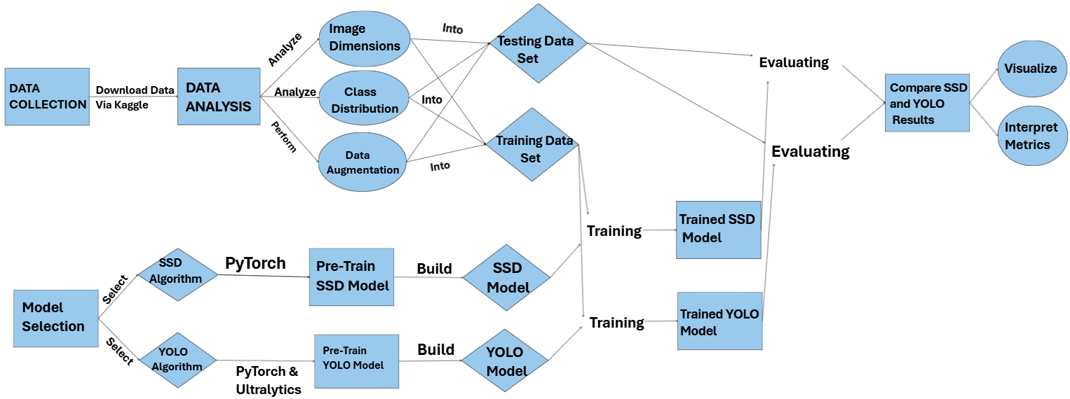Fig. 5: Workflow diagram of the project

Results
The results from each model were compared by running an evaluation for each model by calculating and comparing relevant metrics. The recall, mAP@50, and mAP@50-95 for each class as well as their averages are shown in Table 1. From the results it is obvious that the YOLO model outperforms the SSD model in all classes. It was able to learn to localize and classify the objects better. They both struggled with underrepresented classes like bicycle and motorcycle with the YOLO model achieving an mAP50 of 0.217 on bicycles and 0.23 on motorcycles. The SSD only had 0.033 and 0.013 for those two classes. The car class was easily detected by the YOLO model with the mAP50 of 0.743. SSD still struggles but it had its best performance on cars with an MAP50 of 0.44. The other important metric that was compared is the inference time per image. The average inference time for the YOLO model is 2.5ms per image and the average inference time for the SSD model is 7.5ms.
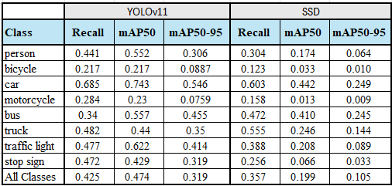
Table 1: Evaluation results for the best performing YOLO model and SSD Model
Confusion matrices were produced for prediction labels for the validation data. Fig. 6 shows the confusion matrix for the YOLO model. Fig. 7 shows the confusion matrix for the SSD model. In both matrices, cars is the most dominant category in terms of frequency. Even though the mAP for cars was the highest there are still many that were missed. There were many objects that were not detected and were counted as background. The IOU confidence threshold for the confusion matrix was set at .50 and the detection confidence was set at 0.25 to match the mAP@50 calculations. Many of the background results include numbers for missed detections as well as low confidence detections and predictions with low IOU. These false negatives numbers can be seen on the bottom “background” row. For example, for the classes that the model could not easily detect more than 65% of instances marked as background. Specifically bicycles, where 854 out of 1150 instances were missed and motorcycles where 729 out of 1049 were also missed by the YOLO model and marked as background. Some wrong predictions are expected such as mixing up vehicles classes like cars, trucks and buses. Other errors such as predicting a person as a car could be due to overlapping objects and are also expected.
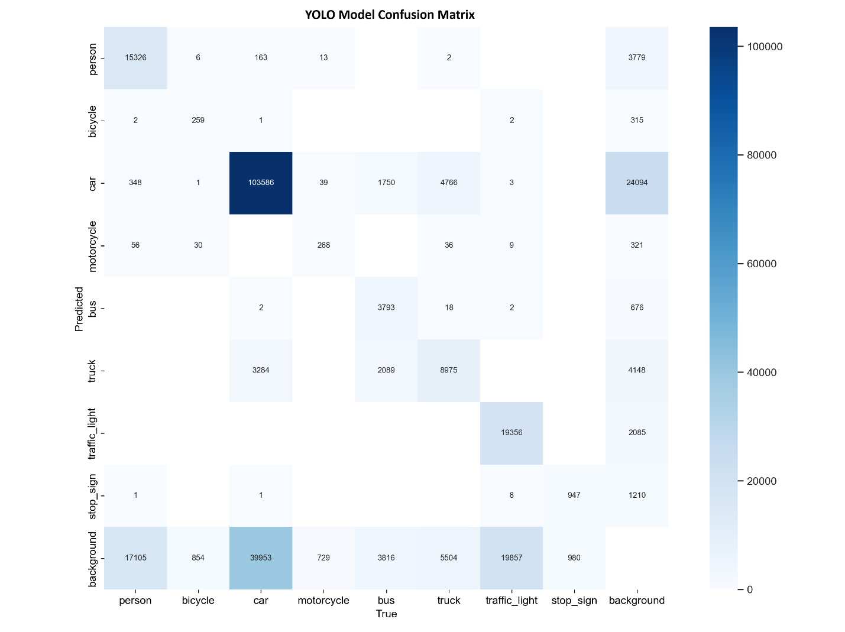
Fig. 6: Confusion matrix for the YOLO model evaluation comparing the ground truth labels in the x-axis with the predicted labels on the y-axis.

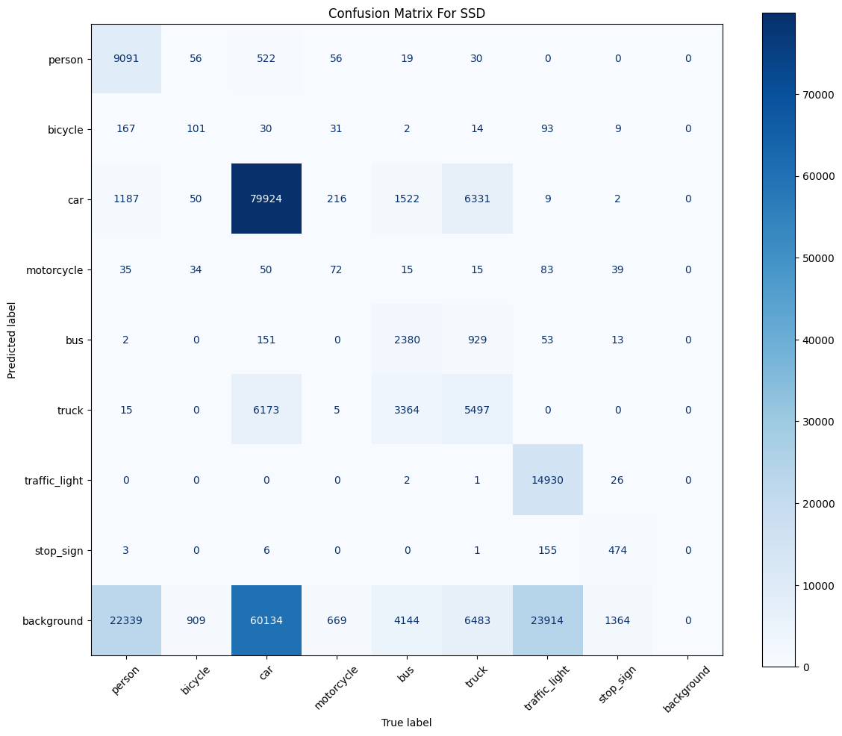
Fig. 7: Confusion matrix for the SSD model evaluation comparing the ground truth labels in the x-axis with the predicted labels on the y-axis.

Conclusion
The primary objective of this project was to compare the performance of the two widely used real-time object detection models YOLO and SSD. This comparison aimed to evaluate how each model performs in terms of detection accuracy and speed, and resource requirements. By comparing a side-by-side analysis under consistent conditions, the project sought to provide insights into when to use each model for real-time object detection.
The main findings of this project indicate that YOLO11 consistently outperformed SSD across all key evaluation metrics as discussed in the results section. In terms of accuracy, YOLO11 achieved a higher mAP@50 score of 0.474 compared to 0.191 and mAP@50:95 score of 0.319 compared to 0.105, demonstrating better object detection. Being a lighter model YOLO also outperformed SSD in inference speed, averaging 2.5 milliseconds compared to 7.5 milliseconds, although both fell below the 16.67 milliseconds required for 60 FPS real-time applications. Lastly YOLO demonstrated superior training efficiency, completing faster training and on less hardware resources than SSD. In contrast SSD showed lower accuracy overall and demanded more computational resources, making it less suitable for deployment in real-world applications.
YOLO is better suited for real-time applications such as autonomous vehicles, and smart surveillance systems where speed and hardware efficiency are critical. Its ability to deliver high accuracy with low inference time makes it a strong candidate for deployment in production environments. While SSD may be less ideal for resource-constrained systems, its architecture with the use of multi-scale feature maps positions as a model with theoretical strengths in detecting smaller objects. In this implementation, the need to resize all input images to 300×300 to conform with the VGG-16 backbone hindered its ability to retain fine-grained spatial details, ultimately reducing its effectiveness in identifying small objects within complex scenes as shown in the results where YOLO outperformed SSD in all classes including smaller objects like bikes, stop signs and traffic lights. Despite its lower performance in this study, SSD provides a valuable architectural contrast and could benefit from future adaptations that preserve higher-resolution inputs.
This project had several limitations that should be acknowledged. The first limitation was the use of pretrained models which limit architecture level modifications which may have impacted potential performance of both models. A second limitation was that training, and evaluations were conducted only on Agrovers-HD dataset. While this dataset is reflective of road scenes it is not reflective of all environments in the real-world. Lastly the project did not include testing in actual deployment scenarios such as real-time video feeds which is important because it limits the understanding of how each model performs under real-world conditions, including variable lighting, motion blur, frame rate constraints, and hardware limitations commonly encountered in live systems.
In conclusion, YOLO11 emerged as the preferred model for real-time object detection tasks. YOLO11 consistently outperformed SSD in accuracy, inference speed and requiring less computational power for training. Therefore, this project recommends using YOLO for real-world applications where responsiveness and precision are the main factors.

References
[1] S. Tennekoon, N. Wedasingha, A. Welhenge, N. Abhayasinghe and I. Murray Am, "Advancing Object Detection: A Narrative Review of Evolving Techniques and Their Navigation Applications," in IEEE Access, vol. 13, pp. 50534-50555, 2025
[2] Ren, Shaoqing, et al. “Faster R-CNN: Towards Real-Time Object Detection with Region Proposal Networks.” IEEE Transactions on Pattern Analysis and Machine Intelligence, vol. 39, no. 6, 1 June 2017, pp. 1137–1149, https://doi.org/10.1109/tpami.2016.2577031.
‌[3] Redmon, Joseph, et al. You Only Look Once: Unified, Real-Time Object Detection. 9 May 2016.
[4] Liu, Wei, et al. SSD: Single Shot MultiBox Detector. 29 Dec. 2016.
[5] mtlics. (n.d.). Argoverse-HD. Kaggle. https://www.kaggle.com/datasets/mtlics/argoversehd
[6] Ultralytics. (n.d.). Argoverse Dataset. Ultralytics YOLO Docs. https://docs.ultralytics.com/datasets/detect/argoverse/#key-features
[7] Conradry. (n.d.). Copy-Paste Augmentation for Segmentation and Detection Tasks. GitHub. https://github.com/conradry/copy-paste-aug​
[8] Zhang, Y., Li, X., & Wang, Z. (2024). YOLOv11: You Only Look Once for Object Detection. arXiv preprint arXiv:2410.17725. https://arxiv.org/abs/2410.17725
[9] Ultralytics. (2024). Ultralytics YOLOv11 (Version 11.0.0) [Computer software]. https://github.com/ultralytics/ultralytics
[10] Koehrsen, W. (2024, September 25). Precision and Recall: How to Evaluate Your Classification Model. Built In. https://builtin.com/data-science/precision-and-recall
[11] Ultralytics. (n.d.). YOLO Performance Metrics. Ultralytics YOLO Docs. https://docs.ultralytics.com/guides/yolo-performance-metrics/

